The Effect of the Pandemic on Domestic Airline Supply and Demand.
Student’s name
Institutional Affiliation

Introduction
Almost all areas of the economy, including the domestic airline, have suffered from the Covid 19 pandemic. Domestic airlines are believed to operate in the same state and are therefore cheaper and shorter than international airlines. The latest global dangers in all markets influenced the sector by the COVID-19 pandemic. One of the first companies affected is the domestic aviation industry since the disease spreads rapidly to humans. To date, the epidemic has not been formally handled, and the population of the world has an enormous concern. Since then, the stock cap of the airline company has fallen. This incidence leads us to evaluate the influence of COVID-19 on the efficiency of the domestic airline business. As government and industry restraints in aviation are relieved, the protocols established out by relevant industries and the authorities are crucial to monitoring and managing hazards like the COVID-19 pandemic in a consistent way. Each component from airport departure and arrival, aircraft, and other supply chain operators requires dependable, practical passenger travel hazards.
After abolishing travel restrictions, the once prosperous business travel industry can also be permanently modified when businesses get used to a less expensive, more efficient, and safe video conferencing option. Moreover, rising levels of unemployment will hinder expenditure on the market, lousy passenger morality, and the ongoing lousy publicity. This paper aims to monitor how Covid 19 has dramatically impacted the demand and supply of domestic flights in ways such as the reduced demand from the customers and the decreased supply to the available customers, mainly due to the set traveling restrictions and regulations. On both the supply as well as demand sides, there has been an impact. Calculating the implications on demand-side passenger counts demonstrates this. Despite the estimates, passenger demand is expected to drop by 48 percent to 85 percent by 2020. On the supply side, passenger seat capacity might drop by 71 percent globally and 51 percent locally. Europe, Africa, and the Middle East are expected to reduce domestic aircraft capacity significantly. In terms of revenue, it is estimated that there will be a 60% drop in sales. The aviation industry is responsible for more than 65 million jobs around the world. Airline firms tend to face additional expenditures due to the installation of sanitization services and infrared thermometers due to COVID-19.
The corporations have suffered considerable losses as a result of this. Because of all of this, some airports/airport terminals have practically closed their business sales. The majority of governments responded by establishing regulations restricting domestic and international travel, and as of April 6, 2020, 96 percent of all domestic airline locations had limitations. On the other hand, many airports remain open for cargo handling to maintain the air cargo industry's stability, which is critical for many households, towns, and businesses. Furthermore, many clients are concerned about their health and choose to stay at home rather than travel. Passenger airlines have been crippled, resulting in significant losses.
Covid 19 has decreased demand for domestic flights; this is due to the travel restrictions introduced because of the rapid spread of the disease. The COVID-19 pandemic had a fundamental impact on the domestic aircraft sector due to tour regulations and a drop in traveler calls. Significant decreases in passenger diversity resulted in the elimination of flights or empty airplanes between airports and decreased the number of airways, and caused many airways to defer their workforce or to claim three insolvencies. To reduce losses, others have tried to prevent refunds for canceled flights. Airlines and airport operators to have laid-off staff. The massive decline in demand for passenger air travel due to the COVID-19 epidemic and containment measures is jeopardizing the survival of several companies in the airline transport industry and the rest of the domestic aviation industry, expose many jobs at risk. Although the aviation industry has long been a focus of government policy, the COVID-19 issue has led to a fresh round of loans, loan guarantees, wage subsidies, and equity infusions, raising questions about competition and also better usage of public funds. These restrictions have led to a reduction in the number of passengers and, thus, many domestic flights with only a few people are canceled or flown. Reduced passenger numbers have resulted in lower revenues, forcing people to be laid off and increasing losses.
However, covid 19 has increased prices for domestic flights. As more countries remove their Covid-19 restrictions, emphasis is moving back to the domestic aviation industry, which has been virtually shut down for months. Some passenger airlines have maintained skeleton fleets flying for repatriation flights (Suau-Sanchez, 2020). In contrast, others have switched passenger jets to cargo flights, but all would prefer to return to their primary role of safely transporting people around the country. According to The Economist (2020), with the reduced number of passengers, domestic flights have opted to increase their charges on flights to help in increasing their income. Domestic airlines are highly dependent on the economy, which means that with the fall of many passengers, the economy will obtain very little from the domestic sector; therefore, to cater to this loss, the airline sector has to hike the prices of domestic flights.
Moreover, covid 19 has resulted in a decrease in the number of available domestic flights. To prevent the spread of the Covid 19 disease, many people are discouraged from making regular flights. Also, due to the lower number of passengers, the number of flights that take off has decreased. Following the various measures imposed by the different governments to curb the spread of the pandemic, the government has ensured minimal flights, and this has therefore discouraged many people from making regular visits (Rooley, 2020). The government's regulations and also the rules on individual travel have resulted in a reduction in the number of flights available. This will therefore have a negative impact on the economy of the country. However, through the imposed measures, the government may only allow very few people to travel to obtain social distance. The COVID 19 epidemic is affecting several organizations in the domestic airline business throughout the world. Different airlines and countries responded to the outbreak in different ways, and they all utilize different strategies. Both domestic and international aviation passengers have decreased in general (Gallego,2020). About half of all passenger traffic is expected to be lost, resulting in a 57 percent drop in airport revenue. All domestic and foreign airlines were predicted to experience a 48 percent drop in revenue passenger kilometers. To address the social distancing and decrease the spread of covid 19, the government expects planes to carry fewer passengers. Therefore, this negatively impacts the economy of the state compared to the regular days.
However, Covid 19 has led to challenges when it comes to forecasting the demand for domestic flights. This is because there are laid down measures that limit freedom when it comes to making regular domestic flights. Moreover, the actual revenue management forecast has been used for years and has been reported to become less relevant due to the changes in Covid 19 (Rooley, 2020). The curves and logistics used in the past have become irrelevant due to the irrelevance and lack of validity of the previously trained data. This means that estimating the income generated from the local flights is somehow tricky. Consequently, the traditional ways of forecasting are being affected by the current environment of the high volatility of schedules and the restrictions on travel that have been put in place.
Nevertheless, Covid has increased the demand for cargo flights that operate domestically. Because people with the country are willing to transport cargo goods to different parts of the country, Cargo flights have increased due to the need for people to transport their goods within the country. The increase in the number of cargo flights has been a replacement for passenger flights. After abolishing travel restrictions, the once prosperous business travel industry can also be permanently modified when businesses get used to a less expensive, more efficient, and safe video conferencing option. Moreover, rising levels of unemployment will hinder expenditure on the market, lousy passenger morality, and the ongoing lousy publicity. This paper aims to monitor how Covid 19 has dramatically impacted the demand and supply of domestic flights in ways such as the reduced demand from the customers and the decreased supply to the available customers, mainly due to the set traveling restrictions and regulations. On both the supply as well as demand sides, there has been an impact. Calculating the implications on demand-side passenger counts demonstrates this. The airports can acquire profits due to the cargo flights and, therefore, cater to some of their expenses.
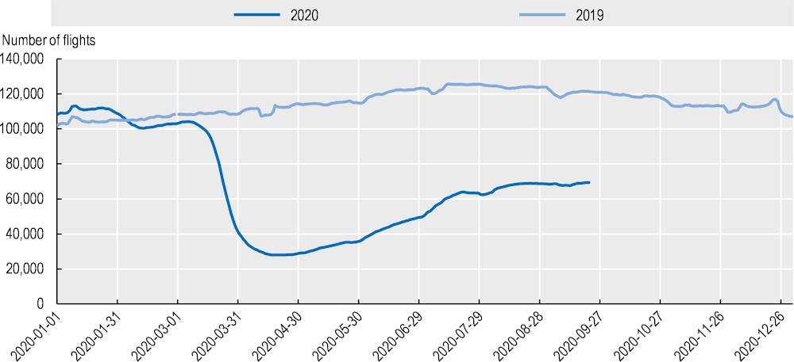
Conclusion
Finally, COVID-19 is a major pandemic that requires immediate action. Governments have devised policies to protect their citizens, some of which include a complete lockdown and the donning of protective masks. Moreover, covid 19 has resulted in a decrease in the number of available domestic flights. To curb the spread of the Covid 19 disease, many people are discouraged from making regular flights. Changes in domestic airline behavior in response to the COVID 19 crises travel restrictions and the ensuing economic crisis resulted in a significant drop in demand for airline services. Some countries, such as India, have ceased stamping passports due to health and safety concerns. Domestic flights have been impacted by Covid 19, which has influenced demand and the supply for domestic flights. To wide up, Covid 19 has had a significant impact on the demand and also the supply of domestic flights, resulting in lower demand from customers and lower supply to available customers, owing to the imposed limits and rules. The establishment of social distance barriers is one of the innovative and creative ideas implemented to combat the epidemic. These are designed to keep passengers safe from one another on planes, lowering the risk of disease transmission. To mitigate the effects of COVID-19 on the passengers' airline, the domestic airline organization will take additional innovative steps, such as increasing the influx of plane cargo.

References
Businesswire. (2020). Impact of COVID-19 on the Aviation Industry, 2020: Historical Market Growth Estimations, and Deviations in the Growth Rate Post-COVID-19 Pandemic. Retrieved from https://www.businesswire.com/news/home/20200422005684/en/Impact-of-COVID-19-on-the-Aviation-Industry-2020-Historical-Market-Growth-Estimations-and-Deviations-in-the-Growth-Rate-Post-COVID-19-Pandemic---ResearchAndMarkets.com
Gallego, I., & Font, X. (2020). Changes in air passenger demand as a result of the COVID-19 crisis: using Big Data to inform tourism policy. Journal of Sustainable Tourism, 1-20.
Rooley, J. (2020). How COVID-19 has affected the aviation industry and its approach to risk. Retrived from https://www.willistowerswatson.com/en-GB/Insights/2020/06/how-covid-19-has-affected-the-aviation-industry
Suau-Sanchez, P., Voltes-Dorta, A., & Cugueró-Escofet, N. (2020). An early assessment of the impact of COVID-19 on air transport: Just another crisis or the end of aviation as we know it?. Journal of Transport Geography.Gebrekidan, s., Bennhold, K., Apuzzo, M. & Kirkpatrick, D. (2020). Ski, Party, Seed a Pandemic: The Travel Rules That Let Covid-19 Take Flight. Retrived form https://www.nytimes.com/2020/09/30/world/europe/ski-party-pandemic-travel-coronavirus.html?searchResultPosition=1
The Economist. (2020). Coronavirus is grounding the world’s airlines. Retrived form https://www.economist.com/business/2020/03/15/coronavirus-is-grounding-the-worlds-airlines
The Economist. (2020). The new coronavirus could have a lasting impact on global supply chains. Retrived form https://www.economist.com/international/2020/02/15/the-new-coronavirus-could-have-a-lasting-impact-on-global-supply-chains

